Name: ______________________________________________ Date: _________________ Block: ________
DIRECTIONS: 1. Highlight or underline important details that may give you hints about the author’s message to you, the reader. 2. Identify the central idea and 3 most relevant details that the author uses to best help develop this.

Your iPhone Was Built, In Part, By 13 Year-Olds Working 16 Hours A Day for 70 Cents An Hour*
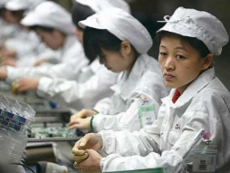
(Henry Blodget, Business Insider, January 15, 2012)
We love our iPhones and iPads.
We love the prices of our iPhones and iPads.
We love the super-high profit margins of Apple, Inc., the maker of our iPhones and iPads.
And that's why it's disconcerting to remember that the low prices of our iPhones and iPads — and the super-high profit margins of Apple — are only possible because our iPhones and iPads are made with labor practices that would be illegal in the United States.
And it's also disconcerting to realize that the folks who make our iPhones and iPads not only don't have iPhones and iPads (because they can't afford them), but, in some cases, have never even seen them.
This is a complex issue. But it's also an important one. And it's only going to get more important as the world's economies continue to become more intertwined.
(And the issue obviously concerns a lot more companies than Apple. Almost all of the major electronics manufacturers make their stuff in China and other countries that have labor practices that would be illegal here. One difference with Apple, though, is the magnitude of the company's profit margin and profits. Apple could afford to pay its manufacturers more or hold them to higher standards and still be extremely competitive and profitable.)
Last week, PRI's "This American Life" did a special on Apple's manufacturing. The show featured (among others) the reporting of Mike Daisey, the man who does the one-man stage show "The Agony and the Ecstasy of Steve Jobs," and The NYT's Nicholas Kristof, whose wife's family is from
China.
You can read a transcript of the whole show here. Here are some details:
- The Chinese city of Shenzhen is where most of our "crap" is made. 30 years ago, Shenzhen was a little village on a river. Now it's a city of 13 million people — bigger than New York.
- Foxconn, one of the companies that builds iPhones and iPads (and products for many other electronics companies), has a factory in Shenzhen that employs 430,000 people.
- There are 20 cafeterias at the Foxconn Shenzhen plant. They each serve 10,000 people.
- One Foxconn worker Mike Daisey interviewed, outside factory gates manned by guards with guns, was a 13-year old girl. She polished the glass of thousands of new iPhones a day.

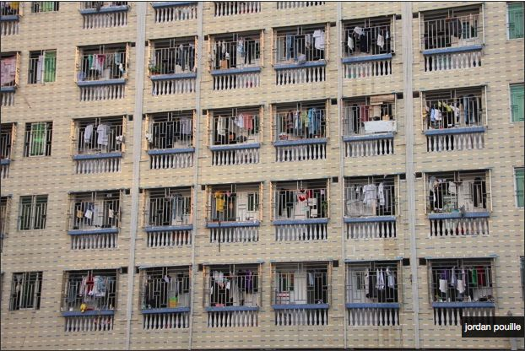
- The 13-year old said Foxconn doesn't really check ages. There are on-site inspections, from time to time, but Foxconn always knows when they're happening. And before the inspectors arrive, Foxconn just replaces the young-looking workers with older ones.
- In the first two hours outside the factory gates, Daisey meets workers who say they are 14, 13, and 12 years old (along with plenty of older ones). Daisey estimates that about 5% of the workers he talked to were underage.

The dormitories. Jordan Pouille

- Daisey assumes that Apple, obsessed as it is with details, must know this. Or, if they don’t, it’s because they don’t want to know.
- Daisey visits other Shenzhen factories, posing as a potential customer. He discovers that most of the factory floors are vast rooms filled with 20,000-30,000 workers apiece. The rooms are quiet: There's no machinery, and there's no talking allowed. When labor costs so little, there's no reason to build anything other than by hand.
- A Chinese working "hour" is 60 minutes — unlike an American "hour," which generally includes breaks for Facebook, the bathroom, a phone call, and some conversation. The official work day in China is 8 hours long, but the standard shift is 12 hours. Generally, these shifts extend to 14-16 hours, especially when there's a hot new gadget to build. While Daisey is in Shenzhen, a Foxconn worker dies after working a 34-hour shift.
- Assembly lines can only move as fast as their slowest worker, so all the workers are watched (with cameras). Most people stand.
- The workers stay in dormitories. In a 12-by-12 cement cube of a room, Daisey counts 15 beds, stacked like drawers up to the ceiling. Normal-sized Americans would not fit in them.
- Unions are illegal in China. Anyone found trying to unionize is sent to prison.
- Daisey interviews dozens of (former) workers who are secretly supporting a union. One group talked about using "hexane," an iPhone screen cleaner. Hexane evaporates faster than other screen cleaners, which allows the production line to go faster. Hexane is also a neuro-toxin. The hands of the workers who tell him about it shake uncontrollably.
- Some workers can no longer work because their hands have been destroyed by doing the same thing hundreds of thousands of times over many years (mega-carpal-tunnel). This could have been avoided if the workers had merely shifted jobs. Once the workers' hands no longer work, obviously, they're canned.
- One former worker had asked her company to pay her overtime, and when her company refused, she went to the labor board. The labor board put her on a black list that was circulated to every company in the area. The workers on the black list are branded "troublemakers" and companies won't hire them.
- One man got his hand crushed in a metal press at Foxconn. Foxconn did not give him medical attention. When the man's hand healed, it no longer worked. So they fired him. (Fortunately, the man was able to get a new job, at a wood-working plant. The hours are much better there, he says — only 70 hours a week).
- The man, by the way, made the metal casings of iPads at Foxconn. Daisey showed him his iPad. The man had never seen one before. He held it and played with it. He said it was "magic."
Importantly, Shenzhen's factories, as hellish as they are, have been a boon to the people of China. Liberal economist Paul Krugman says so. NYT columnist Nicholas Kristof says so. Kristof's wife's ancestors are from a village near Shenzhen. So he knows of what he speaks. The "grimness" of the factories, Kristof says, is actually better than the "grimness" of the rice paddies.
So, looked at that way, Apple is helping funnel money from rich American and European consumers to poor workers in China. Without Foxconn and other assembly plants, Chinese workers might still be working in rice paddies, making $50 a month instead of $250 a month (Kristof's estimates. In 2010, Reuters says, Foxconn workers were given a raise to $298 per month, or $10 a day, or less than $1 an hour). With this money, they're doing considerably better than they once were. Especially women, who had few other alternatives.
But, of course, the reason Apple assembles iPhones and iPads in China instead of America, is that assembling them here or Europe would cost much, much more — even with shipping and transportation. And it would cost much, much more because, in the United States and Europe, we have established minimum acceptable standards for the treatment and pay of workers like those who build the iPhones and iPads.
Foxconn, needless to say, doesn't come anywhere near meeting these minimum standards.
If Apple decided to build iPhones and iPads for Americans using American labor rules, two things would likely happen:
- The prices of iPhones and iPads would go up
- Apple's profit margins would go down
Neither of those things would be good for American consumers or Apple shareholders. But they might not be all that awful, either. Unlike some electronics manufacturers, Apple's profit margins are so high that they could go down a lot and still be high. And some Americans would presumably feel better about loving their iPhones and iPads if they knew that the products had been built using American labor rules.
In other words, Apple could probably afford to use American labor rules when building iPhones and iPads without destroying its business.
So it seems reasonable to ask why Apple is choosing NOT to do that.
(Not that Apple is the only company choosing to avoid American labor rules and costs, of course — almost all manufacturing companies that want to survive, let alone thrive, have to reduce production costs and standards by making their products elsewhere.)
The bottom line is that iPhones and iPads cost what they do because they are built using labor practices that would be illegal in this country — because people in this country consider those practices grossly unfair.
That's not a value judgment. It's a fact.
So, next time you pick up your iPhone or iPad, ask yourself how you feel about that.
UPDATE: On March 16, This American Life announced that it was retracting the episode that the information below is based on because its primary source, Mike Daisey, lied about several incidents.
The gist of the story remains true and has been confirmed by many others. But some of the particularly striking details were apparently fabricated.

Central Idea: _________________________________________________________________________________________________________________________________________________________________________________________________________________________________________________________________________________________________________________________________________________________________________________________________

3 Relevant, Supporting Details (Quotes – Text Evidence):

- ________________________________________________________________________________________________________________________________________________________________________________________________________________________________________________________________________________________________________________________________________________________________________

- ________________________________________________________________________________________________________________________________________________________________________________________________________________________________________________________________________________________________________________________________________________________________________

- ________________________________________________________________________________________________________________________________________________________________________________________________________________________________________________________________________________________________________________________________________________________________________

