The Guitarist by Pablo Picasso
1
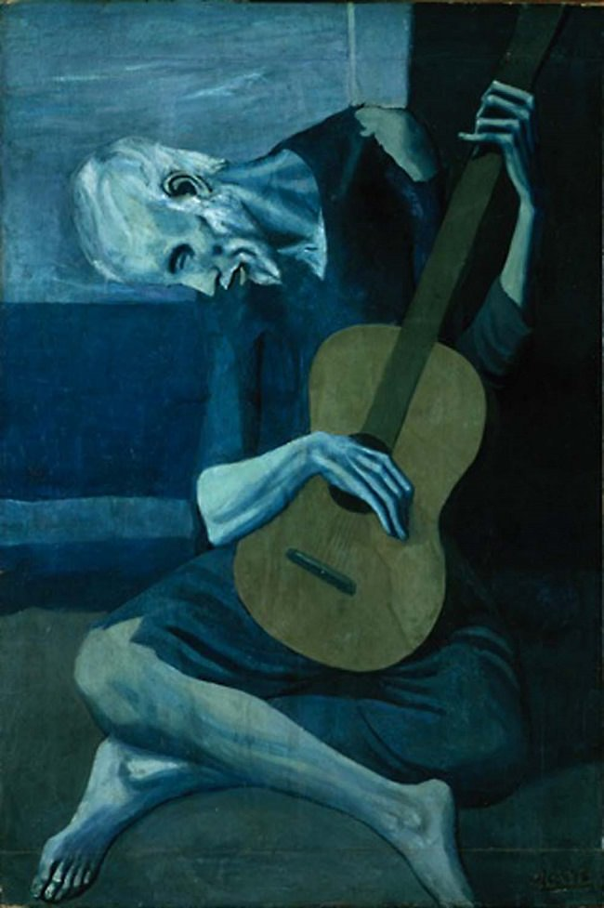
The Old Guitarist was painted in 1903, just after the suicide death of Picasso's close friend, Casagemas. During this time, known as Picasso’s Blue Period, the artist was sympathetic to the plight of the downtrodden and painted many canvases depicting the miseries of the poor, the ill, and those cast out of society. He too knew what it was like to be impoverished, having been nearly penniless during all of 1902. This bent and sightless man holds close to him a large, round guitar. Its brown body represents the painting's only shift in color. Both physically and symbolically, the instrument fills the space around the solitary figure, who seems oblivious to his blindness and poverty as he plays. Also appearing as a metaphor for the need to immerse oneself fully in one's grief in order to heal.
Undying Death by Alexandra Manukyan
3
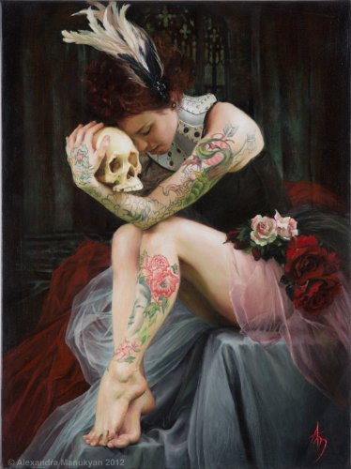
This artists paintings explore the false facades or masks we all create to adapt and belong but that also makes us blind and lost in a world where the meaningless has somehow become meaningful and the idea of a shared honest self, devoid of hidden agendas is uncommon. In this particular painting, the crushing pain of lost loves, costly betrayals, and ensuing isolation all build a path of sorrow and fear. Even with the passage of time she remains haunted by the lingering memories of regret that numb her soul like an undying death.
A Character by Tetsuya Ishida
4
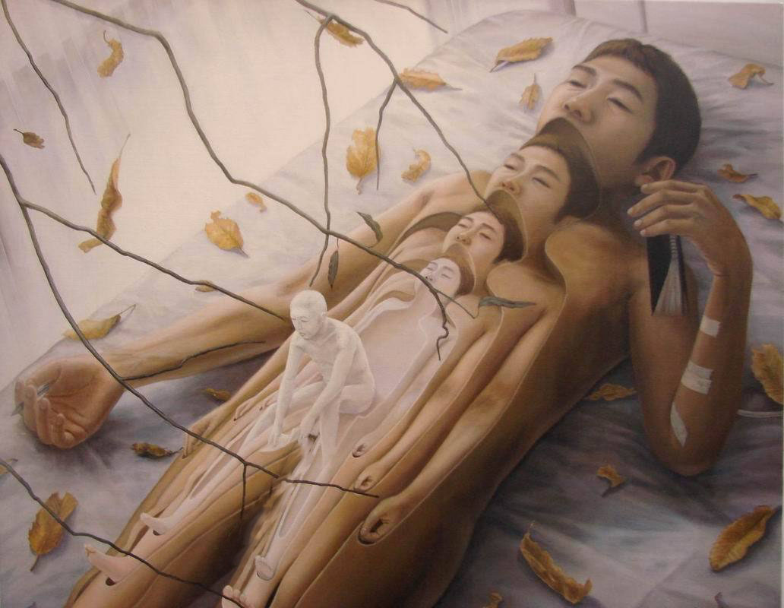
This author’s fame comes from his brilliant characterizations of Japanese society and the personal isolation that resulted from the country’s economic downturn through the 90s. “Ishida captured the feelings of hopelessness, claustrophobia, and emotional isolation that burdened him and that dominated Japanese society during this era.”
I notice a lot of things here: the leaves dying and falling from the branches, the arm bandages, the numerous layers of the person (empty/hollow, except for the smallest one and growing lighter to a ghostly pale), no mouth except for the smallest one…

Isolation by Isabella Morawetz
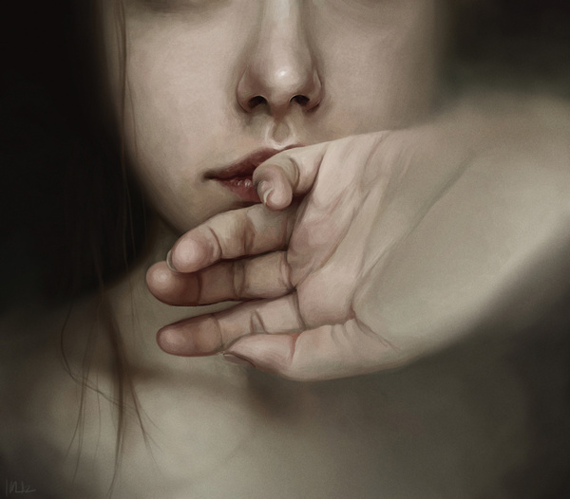
2
This piece of art is very open to interpretation as I cannot find anything on the internet that explains the author’s intentions. Here is what stands out to me: I only see part of her (which makes me feel like people may not really see her), I see a hand that partially covers her mouth and yet the palm faces out (this makes me wonder if she feels vulnerable, insecure, and may not have a “voice”), I notice that the edges along one side are blurred and moving inward (this makes me think that she might feel insignificant and may be disappearing). Of course, these are just my interpretations. Art is subjective and there is no one to tell us here who is “right” or “wrong.” What do you think?

Going Towards the Light by Artsgrie
5
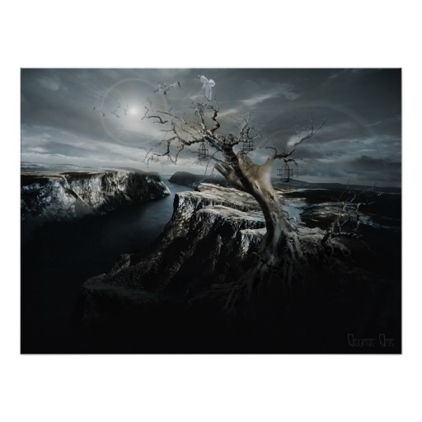
The term “Go toward the light” is traditionally guidance to the dying/deceased person's spirit to go toward heaven, Valhalla, the Elysian Fields, etc. It means going to a superior afterlife, rather than been trapped here on earth as a phantom or even worse. Most of us have heard of the concept of a person feeling like they are in a tunnel and that they are moving towards the light at the end of the tunnel. This visualization acts as an analogy representing the feeling that the person sees a solution or a happy ending at the end of the ordeal they are going through.
There is a lot of symbolism happening here: winter (snow/dead tree), hand superimposed on the tree in the movement of release, open and empty cages, bird heading toward the light.

