Name: __________________________________________ Class Period: _____ Date: ______________

THEME with URBAN LEGENDS – Part 2 (Stories)

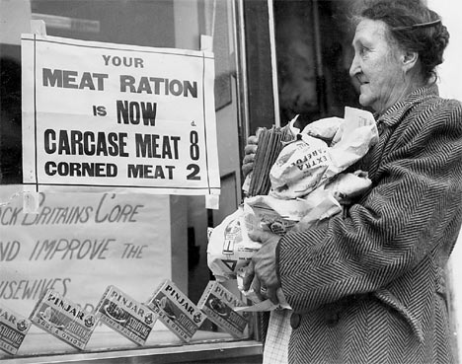
The Last One
In the weeks and months immediately after the end of World War II,
shelter, clothes, fuel, even food were in short supply in Berlin. People
wandered the streets looking for a job or something they could salvage
from the ruins and sell. One day a young woman was scavenging in a
bombed out apartment building when she bumped into a man. She was
about to shout to tell him to watch where he was going, but she stopped
herself. The man wore very dark glasses and held a long white cane in
his hand. The poor man was blind.
"I am so sorry," the woman said. "I should be more careful."
"There is no harm done," the blind man assured her. And so they fell to talking.
"Could I ask you to do a small favor for me? Would you mind delivering this letter? You will have an easier time finding the address than I will," the blind man asked after a few minutes. The woman looked at the address on the envelope. It wasn't too far out of her way.
"Yes," she said. "I can deliver this for you."
"You are very kind," the blind man said. "Now if you will excuse me, I have an appointment."
The young woman watched as the blind man made his way slowly through the crowd. After he had inched his way to a street corner, he suddenly began to run, and as he ran he stuffed his dark glasses into his coat pocket and folded up his white cane.
Suspicious, the young woman looked for a policeman and showed him the letter.
"A man I thought was blind asked me to deliver this for him," the woman said. "but then from the way he ran off it was obvious that he was not blind."
"Let's go to the address and see what happens," the policeman said. He called for help, and with half a dozen police officers the woman went to the mysterious address.
The woman stood at the curb while the policemen surrounded the house. A strange looking man opened the door. When he saw all the police he tried to run, but the officers arrested him. They searched the house, and in freezers in the cellar they found slabs of human flesh, wrapped in butcher's paper and priced for sale.
Out on the street, the policeman opened the envelope and took out the note. "This is the last one I'm sending you today. Treat her like the rest," it read.

The Anxious Tourists
Two elderly ladies who had never traveled out of their home state, Iowa, decided they needed a little excitement in their lives. So they asked a travel agent to arrange a week in New York City. When they landed at La Guardia Airport, two flight attendants walked them to the baggage claim area. "Now be careful in the city," one of the flight attendants said. "Always hold on tightly to your handbag." "And avoid the subway," said the other attendant. "Cabs are more expensive, but they are the safest way to get around town."
The limo driver who took the ladies to their hotel in Midtown had some advice, too. "If you do run into trouble, just do what the man says and you won't get hurt." Naturally, all of this advice made the two out-of-towners a little apprehensive. But after a day or two of sightseeing without any

unpleasant incidents, the ladies decided that New York City was not such a frightening place after all.
Their travel agent had made dinner reservations for them at the Rainbow Room in Rockefeller Center. Feeling bolder, the ladies decided to walk the four blocks from their hotel to the restaurant. But after a block or two, they became uneasy. A very tall, broad-shouldered black man with a Rottweiler was following them. "Let's walk a little faster," said one of the ladies. "Once we're on the elevator, he can't follow us."
So the two friends picked up their pace, hurried through the revolving doors and scurried across the lobby to the bank of elevators that would take them up to the Rainbow Room. As the elevator doors opened, they could hear the man and the dog entering the lobby.
"Hurry! Push the close button!"one of the woman said to the other.
But as the doors began to shut, two strong hands reached in and pried them apart. The man and the dog got on the elevator. He hit the button for the penthouse. There was no place for the ladies to go. They backed into a corner of the elevator car, clutching their handbags and looking nervously at the Rottweiler that sniffed at their feet.
Suddenly the man said, "Sit Lady!"
Both women plopped down on the floor.
At that moment, the elevator came to a stop and the doors opened onto the lobby of the Rainbow Room. The man with the dog called to the hostess, "Could you help these ladies to their feet and escort them to their table."
"We were so frightened," one of the ladies confided to the hostess. "He shouted, 'Sit lady!' and we did just what he said."
"Oh ma'am. The gentleman wasn't talking to you," the hostess replied. "He was just giving a command to his dog. His dog's name is Lady."
"But how do you know all of this?" the other lady asked.
"The gentleman lives in the penthouse. We seem him and his dog all the time. Didn't you recognize him? That was Michael Jordan."

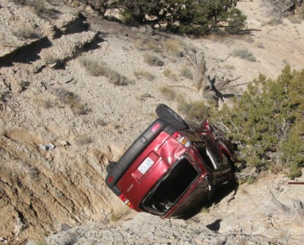

A Mother's Plea
A couple taking a drive in the country came across a woman
standing in the middle of the road waving her arms wildly. As they
drew closer they could see that she was bruised and bleeding, and
her clothes were torn. The couple stopped the car and jumped out
as the distraught woman ran toward them. "My family has been in
a terrible car accident. We went off the road and into the ravine.
My husband's dead, but my baby is still alive. Please, save my baby."
The man charged down the steep slope of the ravine. At the bottom,
he found the battered car with two dead adults in the front seat and an infant, still strapped in her car seat, bawling but unharmed. He lifted the child out of the car and carried her carefully back to the road.
"Where's the mother?" the man asked his wife.
"She followed you down the ravine. Didn't you see her?"
The man handed the baby to his wife, and returned to the wrecked car. In the front seat were a dead man and a dead woman - the same woman who had flagged him down a few minute earlier.

***Hope you had fun! If you feel like you could use more practice with theme, just grab any book of fiction (or urban legend) for extra practice.***

