Name: ______________________________________________ Date: _________________ Block: ________
DIRECTIONS: 1. Highlight or underline important details that may give you hints about the author’s message to you, the reader. 2. Identify the central idea and 3 most relevant details that the author uses to best help develop this.

Stem Cells in Court, Scientists Fear for Careers

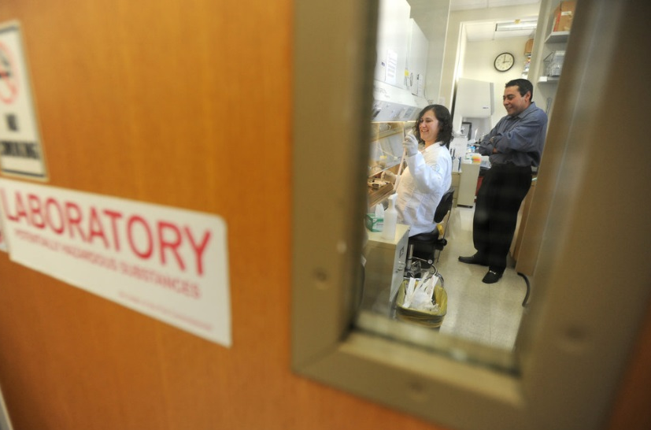
(Amy Harmon, New York Times, October 5, 2010)

Rushing to work at Cincinnati Children’s Hospital Medical Center one recent morning, Jason Spence, 33, grabbed a moment during breakfast to type “stem cells” into Google and click for the last 24 hours of news. It is a routine he has performed daily in the six weeks since a Federal District Court ruling put the future of his research in jeopardy.
“It’s always at the front of my brain when I wake up,” said Dr. Spence, who has spent four years training to turn stem cells derived from human embryos into pancreatic tissue in the hope of helping diabetes patients. “You have this career plan to do all of this research, and the thought that they could just shut it off is pretty nerve-racking.”
Perhaps more than any other field of science, the study of embryonic stem cells has been subject to ethical objections and shaped by political opinion. But only a year after the Obama administration lifted some of the limits imposed by President George W. Bush, a lawsuit challenging the use of public money for the research and a conservative shift in Congress could leave the field more sharply restricted than it has been since its inception a decade ago. At stake are about 1,300 jobs, as well as grants from the National Institutes of Health that this year total more than $200 million and support more than 200 projects.
The turn of events has introduced what researchers say is unprecedented uncertainty to a realm of academic science normally governed by the laws of nature and the rules of peer review.

“We’re used to people telling us, ‘That was a stupid idea, we’re not going to fund it,’ and we turn around and think of a better one,” said James Wells, who heads the laboratory where Dr. Spence has a postdoctoral position. “But there’s nothing we can do about this.”
The stem cells, which are thought to have curative potential for many diseases because they can be turned into any kind of tissue in the human body, can be obtained only by destroying a human embryo, which many Americans believe is the equivalent of a life.
In August, Chief Judge Royce C. Lamberth of Federal District Court for the District of Columbia found that the Obama administration’s policy violates a law barring federal financing for “research in which a human embryo or embryos are destroyed, discarded or knowingly subjected to risk of injury or death,” and issued an injunction blocking federal money for the research.
Since then, the field’s fate has appeared to shift almost weekly as the lawsuit wends its way through the courts. Last week, the

government won the right from an appeals court to continue financing the contested research while it appeals the ruling. But there is no telling how the appeals court will ultimately rule, and Judge Lamberth could issue a revised injunction.
Many of the nation’s leading stem cell researchers do not know whether they will receive grants they won years earlier through the standard competition, or whether new projects will even be considered. Junior scientists like Dr. Spence, poised to start their own laboratories, are caught in limbo. Senior scientists like Dr. Wells are torn between pursuing research they believe in and protecting students from staking their job prospects on projects they may never be able to complete.
The legal roller coaster is raising stress levels and reducing productivity, researchers say. Instead of tending to their test tubes, they find themselves guessing how each member of the Supreme Court might vote on the case. They are also watching the midterm Congressional elections with new interest — and with some dismay, since many believe that new legislation will be required for their work to continue.
Under guidelines authorized by both the Bush and Obama administrations, work that leads directly to destroying the embryos cannot be federally financed. The government can, however, support subsequent research on the cell lines created by that process.
Last year, two scientists filed the lawsuit, arguing that the distinction is a false one and that the guidelines on public financing violated the Dickey-Wicker amendment, first passed in 1996 and renewed by Congress every year since.
Moreover, they said, it siphons limited government resources from research on different types of stem cells, which they and other scientists who share a discomfort with embryonic stem cells view as ethically and scientifically superior. For all the hope vested in them, human embryonic stem cells have yet to yield tangible results for patients.
In his ruling, Judge Lamberth agreed that the guidelines violated the 1996 amendment and “threaten the very livelihood” of the plaintiffs.
Embryonic stem cell researchers who stand to lose their federal grants as a result argue that other types of stem cells do not have the same properties, and that all need to be studied regardless to determine which work best. They bristle at the intrusion of judges and politicians into decisions usually addressed by the peer review process, in which experts in a field comment on the merit of an idea and the best get financed.
Yet even some who believe there is a compelling scientific rationale for their research agree that the legal basis for federal financing may be weak. “I was astonished that Congress hadn’t dealt with this,” said Stephen Duncan, a stem cell researcher at the Medical College of Wisconsin, who stands to lose several million dollars in federal grants depending on the dispensation of the case. “It’s like being a little pregnant. You’re either breaking the law or you’re not.”
Mr. Bush, who in 2001 limited federally financed researchers to working on roughly two dozen stem cell lines already in existence, twice vetoed legislation that would have explicitly expressed support for financing the contested research. No such legislation has been introduced under President Obama, but the administration expanded the number of stem cell lines researchers could study.
Advocates of the research now see this as a missed opportunity.
Efforts to rally Congressional support since Judge Lamberth’s ruling have failed to gain momentum among Democrats and moderate Republicans heading into the November elections.
For many, the most recent intrusion of politics into the vaunted scientific meritocracy came as a particular shock because the Obama administration’s new guidelines had only months earlier fallen into place.
“The painful thing is that we are being stopped at a time when the velocity of this field of research, thanks to the new administration, was finally going at maximum speed,” said Ali H. Brivanlou, a professor at Rockefeller University.
Over the last few weeks, embryonic stem cell scientists have sought alternative financing from private foundations, university administrations and state programs. But the National Institutes of Health, which has a $26 billion budget, is by far the source with the deepest pockets for academic scientists.
Some researchers are weighing a switch to the private sector. Others have ordered their students to pay no attention to the news. Others are trying to raise public awareness.
Yi Sun, 45, of the University of California, Los Angeles, has resorted to frequent meditation.
“I would be in trouble without it,” said Dr. Sun, whose stem cell work focuses on an autism disorder called Rett syndrome. Born in China, Dr. Sun said she was now renewing efforts to collaborate with well-financed stem cell biologists there.

Central Idea: (Ask yourself: What is the author’s message or point about the topic?) _________________________________________________________________________________________________________________________________________________________________________________________________________________________________________________________________________________________________________________________________________________________________________________________________

3 Relevant, Supporting Details (Quotes/Text Evidence): (Ask yourself: What is your proof?)

- ________________________________________________________________________________________________________________________________________________________________________________________________________________________________________________________________________________________________________________________________________________________________________

- ________________________________________________________________________________________________________________________________________________________________________________________________________________________________________________________________________________________________________________________________________________________________________

- ________________________________________________________________________________________________________________________________________________________________________________________________________________________________________________________________________________________________________________________________________________________________________

