Inference Comic Name: _____________________________
(Making Visual Inferences) Date: ______________ Block: ______

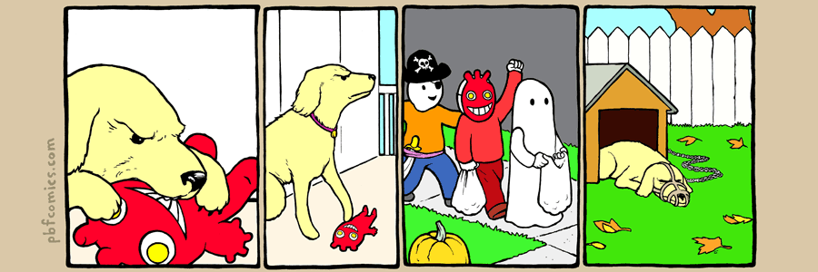
List the facts in each picture frame. ONLY list what you see. Do not jump to any conclusions. You are gathering evidence in order to make an inference later. The first picture is modeled for you.
1. Dog bites toy.
2.
3.
4.
Explain the inference. Something happened that the artist does not show you. This is the joke. What happened and why?

