Warm up:
Maelstrom [meyl-struh m] : noun
1. a large, powerful, or violent whirlpool.
2. a restless, disordered, or tumultuous state of affairs: the maelstrom of early morning traffic.
3. (initial capital letter) a famous hazardous whirlpool off the NW coast of Norway.

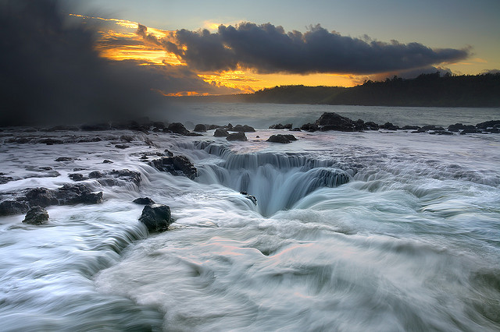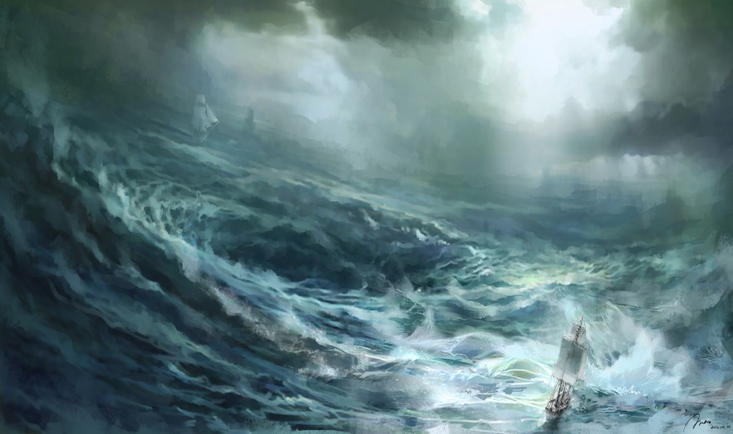

THINK/WRITE/PAIR/SHARE: (on a sheet of paper – attach to this worksheet)
  - Look at the following pictures with another person.
  - Imagine that you are on a boat next to a maelstrom. (See images above.)
  - Create a list of words that you would use to describe how you would feel in that situation. (Have another person do the same thing – WITHOUT talking to you about it first.)
  - Share your list with your partner and determine if you can find a pattern to identify a
theme (recurring idea).
  - Possible theme(s): _______________________________________________________________

----------------------------------------------------------------------------------------------------------------------------------------------------------------

SHORT SUMMARY (Synopsis)
The story opens in the year 1866. Everyone in Europe and America is talking about a mysterious creature that has been sinking ships. Finally, the United States government decides to intervene and commissions the Abraham Lincoln to capture and identify the creature.
The Abraham Lincoln is attacked by the creature. Aronnax, Conseil and Land go overboard. The three men find themselves on top of the mysterious creature, which is actually a submarine vessel. They are taken on board and placed in a cell. The men meet Captain Nemo, the commander of the vessel, known as the Nautilus. He tells them they can stay on board the ship and enjoy freedom as long as they return to the cell if asked. They are never to leave the vessel again.
During their time on the Nautilus, the men experience many exciting adventures. They hunt in underwater forests, visit an island with angry natives, visit the lost city of Atlantis, and fish for giant pearls. However, there are also many distressing events coupled with the erratic behavior of Captain Nemo.
One night, while off the coast of Norway, Aronnax, Conseil and Land plan a rash escape. To their dismay they realize they are heading toward a giant whirlpool--one that no ship has ever survived. Amazingly, in only a small dinghy they emerge safely. They awake in the hut of a fisherman. At the conclusion of the story, Aronnax is awaiting his return to France and rewriting his memoirs of his journey under the sea.

20,000 Leagues Under the Sea: Word Choice/Tone/Theme (Steps 1-5)

NAME:________________________________________________ BLOCK: _______ DATE:_____________
Assignment FOCUS:
- I can determine the meaning of words and phrases as they are used in the text, including figurative and connotative meanings, and analyze the cumulative impact of specific word choices on meaning and tone. (RL.2.4)
- I can determine a theme or central idea of a text and analyze in detail its development over the course of the text, including how it emerges and is shaped and refined by specific details; provide an objective summary of the text. (RL.1.2)

1. WARM UP: See power point slide (Maelstrom); also found on the back of this packet.
2. READING TASK: As you read, underline words and/or phrases that the author uses to create a fearful tone.
Circle any words that you do not know.

Excerpt from 20,000 Leagues Under the Sea
By Jules Verne
Smithsonian Magazine
August 2001
From Chapter XLVI,
Captain Nemo's Last Words
1

2

3

4

5

6

7

8

The Canadian paused in his work. But one word twenty times repeated, one dreadful word, told me the reason for the agitation spreading aboard the Nautilus. We weren't the cause of the crew's concern.
"Maelstrom! Maelstrom!" they were shouting. One word twenty times repeated...Maelstrom.
The Maelstrom! Could a more frightening name have rung in our ears under more frightening circumstances? Were we lying in the dangerous waterways off the Norwegian coast? Was the Nautilus being dragged into this whirlpool just as the skiff was about to detach from its plating?
As you know, at the turn of the tide, the waters confined between the Varrö and Lofoten Islands rush out with irresistible violence. They form a vortex from which no ship has ever been able to escape. Monstrous waves race together from every point of the horizon. They form a whirlpool aptly called "the ocean's navel," whose attracting power extends a distance of fifteen kilometers. It can suck down not only ships but whales, and even polar bears from the northernmost regions.
This was where the Nautilus had been sent accidentally—or perhaps deliberately—by its captain. It was sweeping around in a spiral whose radius kept growing smaller and smaller. The skiff, still attached to the ship's plating, was likewise carried around at dizzying speed. I could feel us whirling. I was experiencing that accompanying nausea that follows such continuous spinning motions. We were in dread, in the last stages of sheer horror, our blood frozen in our veins, our nerves numb, drenched in cold sweat as if from the throes of dying! And what a noise around our frail skiff! What roars echoing from several miles away! What crashes from the waters breaking against sharp rocks on the sea floor, where the hardest objects are smashed, where tree trunks are worn down and worked into "a shaggy fur," as Norwegians express it!
What a predicament! We were rocking frightfully. The Nautilus defended itself like a human being. Its steel muscles were cracking. Sometimes it stood on end, the three of us along with it!
"We've got to hold on tight," Ned said, "and screw the nuts down again! If we can stay attached to the Nautilus, we can still make it . . . !"
He hadn't finished speaking when a cracking sound occurred. The nuts gave way, and ripped out of its socket, the skiff was hurled like a stone from a sling into the midst of the vortex.
My head struck against an iron timber, and with this violent shock I lost consciousness.
From Chapter XLVII
Conclusion
9

10

11

12

13

14

We come to the conclusion of this voyage under the seas. What happened that night, how the skiff escaped from the Maelstrom's fearsome eddies, how Ned Land, Conseil, and I got out of that whirlpool, I'm unable to say. But when I regained consciousness, I was lying in a fisherman's hut on one of the Lofoten Islands. My two companions, safe and sound, were at my bedside clasping my hands. We embraced each other heartily.
Just now we can't even dream of returning to France. Travel between upper Norway and the south is limited. So I have to wait for the arrival of a steamboat that provides bimonthly service from North Cape.
So it is here, among these gallant people who have taken us in, that I'm reviewing my narrative of these adventures. It is accurate. Not a fact has been omitted, not a detail has been exaggerated. It's the faithful record of this inconceivable expedition into an element now beyond human reach, but where progress will someday make great inroads.
Will anyone believe me? I don't know. Ultimately it's unimportant. What I can now assert is that I've earned the right to speak of these seas, beneath which in less than ten months, I've cleared 20,000 leagues in this underwater tour of the world that has shown me so many wonders across the Pacific, the Indian Ocean, the Red Sea, the Mediterranean, the Atlantic, the southernmost and northernmost seas!
But what happened to the Nautilus? Did it withstand the Maelstrom's clutches? Is Captain Nemo alive? Is he still under the ocean pursuing his frightful program of revenge, or did he stop after that latest mass execution? Will the waves someday deliver that manuscript that contains his full life story? Will I finally learn the man's name? Will the nationality of the stricken warship tell us the nationality of Captain Nemo?
I hope so. I likewise hope that his powerful submersible has defeated the sea inside its most dreadful whirlpool, that the Nautilus has survived where so many ships have perished!
3. Words/Phrases T-Chart
(Prep. for constructed response): Answer in complete sentences and FULLY explain your thoughts.
Follow the models and we do, as a guide.

Word / Phrase Impact on meaning and tone

"one dreadful word" This phrase fills the reader with a sense of apprehension...what is this
dreadful word that the narrator brings up?

"agitation spreading" When agitation spreads among a group, it means that everyone starts
to feel anxious and afraid about something. This creates a fearful tone
because the reader sees that the crew is becoming agitated about
something still unnamed.

"one word twenty times repeated...maelstrom" (How does the use of dialogue and repetition in this phrase establish the tone?)

"a vortex from which no ship has ever (How does this phrase create a fearful tone?)
been able to escape"

continued…

Words/Phrases T-Chart
(Prep. for constructed response): Answer in complete sentences and FULLY explain your thoughts.
Follow the models and we do, as a guide.

Word / Phrase Impact on meaning and tone
(How does this phrase show that the narrator was fearful out on the open sea?)
"monstrous waves"

(How does this phrase show how the narrator felt about the ship?)
"The Nautilus defended itself like
a human being"

(How does this phrase early in the excerpt create a specific mood in the text?)
"irresistible violence"

4. Consider figurative language…

Verne uses personification when describing how the boat breaks apart in the maelstrom. Why do you think he describes the boat with humanlike traits?

5. Essential Question/Constructed Response (Answer your constructed response in one paragraph using ACES format):

How does Jules Verne use words and phrases to develop a fearful tone in 20,000 Leagues Under the Sea?

______________________________________________________________________________________________________________________________________________________________________________________________________________________________________________________________________________________________________________________________________________________________________________________________________________________________________________________________________________________________________________________________________________________________________________________________________________________________________________________________________________________________________________________________________________________________________________________________________________________________________________________________________________________________________________________________________________________________________________________________________________________________________________________________________________________________________________________________________________________________________________________________________________________________________________________________________________________________
WANT EVEN MORE EXTRA CREDIT POINTS???
Complete the following two extension/synthesis activities of this lesson.

1. Independent Work (building the skill):
Students will independently read pp. 76-81 in Trial by Ice and use the same chart to collect words and phrases that create an apprehensive tone.

Word / Phrase Impact on meaning and tone

-----------------------------------------------------------------------------------------------------------------------------------

2. Answer the RI.2.4-aligned question based on “Trial by Ice”:

How does the sentence "Shackleton gruffly told the young sailor, 'the first person we eat will be you" (photo caption on p. 81) impact the reader's understanding of Shackleton as a leader?

a. It shows that Shackleton likes to play practical jokes on his sailors.
b. It reveals that Shackleton has a violent, threating side to his personality.
c. It shows that Shackleton does not like secrets or surprises when it comes to his crew.
d. It reveals that Shackleton holds grudges and does not forget about misbehavior easily.

