ACES 2.0 (4 Paragraph Planning Sheet) - Argumentative
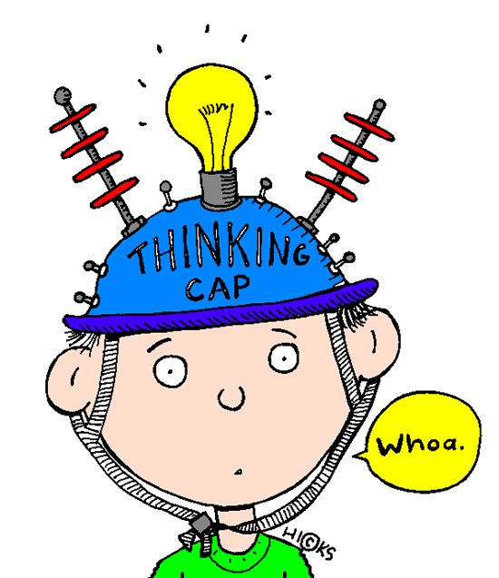
This is a planning sheet that will help you do the ACES 2.0 (4 paragraph argumentative/persuasive essay). Use the two Kaavya articles, your notes, and Evaluating Arguments Chart in order to help you.

Essay Prompt: Argumentative Whose argument did you find more effective? Determine whether reasoning is sound and/or evidence is relevant, sufficient, and true in order to support the text’s claims.
Paragraph # | Ideas
1  Introduction  (Hook = usually 1st sentence of intro., attempts to gain the reader’s attention through a variety of techniques: dialogue, imagery, figurative language, direct characterization, etc.  Bridge = the connecting sentence between the Hook and the Thesis/Claim which narrows the topic closer to the thesis statement.  Touch on your two reasons, explaining what you will cover and prove in your essay, in basic terms.  Claim = your position statement, identifying which side you choose, based on the prompt. Your entire essay will attempt to prove this is correct.) | Hook:  Bridge:  Claim (persuasive):
2  Body  Argumentative = In the first body paragraph, take both or your reasons and fully explore them using ACES. Prove your reasons support your claim beyond a shadow of a doubt.  (The planning sheet is for notes. You will still add more when you actually write the essay.) | Answer the question (Argumentative = Reason #1 & #2)  (Q: What are two good reasons that support your claim?)
Cite Evidence (at least 2 quotes from the text)
(Q: Prove it. What are two specific examples from the text that would support your reasons? Address BOTH texts.)

Explain your reasons
(Q: Why did you choose those text examples? How do they support/back up your reasons? Clarify what you mean by your answer.)

Summary / So What?
(Q: What does this have to do with the big picture? How can you identify deeper connections among ideas and/or to the text as a whole? Drive your point home.)

3*  Counter Claim  Argumentative = Here you will play devil’s advocate but be careful! Addressing the other side of the argument will make your argument stronger IF you make sure that you still prove why yours is the strongest.  4  Conclusion  (You will add more into your conclusion paragraph than just these notes.  Provide a topic sentence that rephrases (NOT repeats) your thesis – says it again in different words. Review your two reasons and the most important points you addressed about each. End with a powerful statement (connection / theme) that will stick with the reader and drive your final argument home.) | Address the other side  (Q: What is the opposite position from your claim? Acknowledge it… “While some may say ________,” …then provide a statement or explanation to show how your argument/side is stronger.)
 | Restate your thesis

Any additional notes / ideas / instructions: ________________________________________________________________________________________________________________________________________________________________________________________________________________________________________________________________________________________________________________________________________________________________________________________________________________________________________________________________________________________________________________________________________________________________________________________________________________________________________________________________
________________________________________________________________________________________________________________________________________________________________________________________________________________________________________________________________________________________________________________________________________________________________________________________________________________

